Months of the year

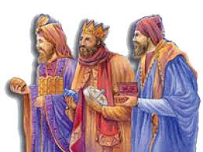
January
January is a first month in a year.
In January is very cold and it snows.
Lots of people go on winter holidays .
On the 6th of January we celebrate visit
of three Kings.
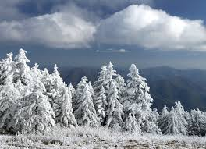
February
February is a last winter month.
February has 28 days but in the leap year
February has 29 days. Sometimes people
go skiing, my family too.
March
In March are Spring holidays.
In March is a first Spring day.
And flowers grow.
I like to play football in March.
April
On the first of April I smile a lot.
In April is very funny weather.
Sun shines, it is windy and it rains a lot.
My family celebrates Easter.
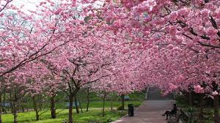
May
In May we celebrate work and in May
it is time of love . On the eight of May
we remember that the 2nd World War
was finished. May is the last spring
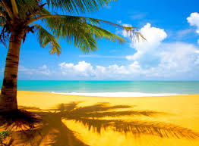
month.
June
I like June, school ends and holiday starts and some families go to holidays. On the twenty-first of June is the first Summer day. The third Sunday is Father´s Day.
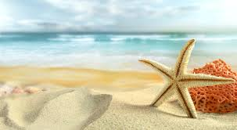
July
July is Summer month. In July usually
families go on Holidays. In July Sun
shines and it is very hot. We go to the sea
or we visit our friends and family.

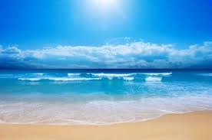

August
August is hot month too. We usually swim in the pool or lakes. Mushrooms grow in the forests. People find them.

September
In September we go to the school
again. September is the first autumn
month. September is ninth month
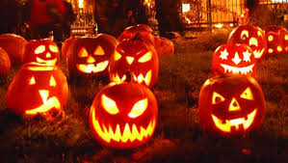
of our year.
October
In October it often rains. It is cold. Leaves fall down. On the 31st of October it is Halloween.
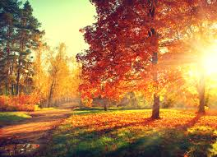
.
November
November is the last autumn month.
In November I have Birthday.
It is very cold. It doesn´t often snow.
December
December is the last month of the year. December is very very cold month. We can
skiing, sledging, make a snowman and it snows. In December it is Christmas. Some people go to the church and have a special dinner. I like Christmas.

Jakub Smažák, 5.A

